**Phipps Conservatory Web Development Assignment**

**Describe three ways in which your design is specifically geared toward the college student user.**

1. It has been updated such that the info has been abridged and presented straight up, so there is not much searching to be done, making the information easy to understand.
2. It is not wordy nor does anything take up too much space, so all the information is clear and presentable such that a college student does not need to take too much time trying to look for something (especially with the grid structure in place)
3. Aesthetically it is very lively and makes use of a lot of images and videos, so it helps to keep the attention of a college student.

**Describe three ways in which your design evolved over several iterations of the assignment. You may want to include specific screenshots of your wireframes to illustrate your response.**

(See Exhibit A on next page to see the changes detailed in 1 and 2)

1. Originally, I was going to use buttons instead of a navbar in order to traverse from page to page. However, aesthetically it wasn’t appealing nor was it visually streamlined, and due to user feedback I decided to change it.
2. I turned the Exhibitions part of my website into an accordion instead of a box because through an accordion I can present more information without taking up too much space.
3. Originally, I was going to put the YouTube video in the gallery page other than the contact us page, but due to the fact that the video was about the location and the structure of Phipps I decided that it would be a better fit in the contact us page.

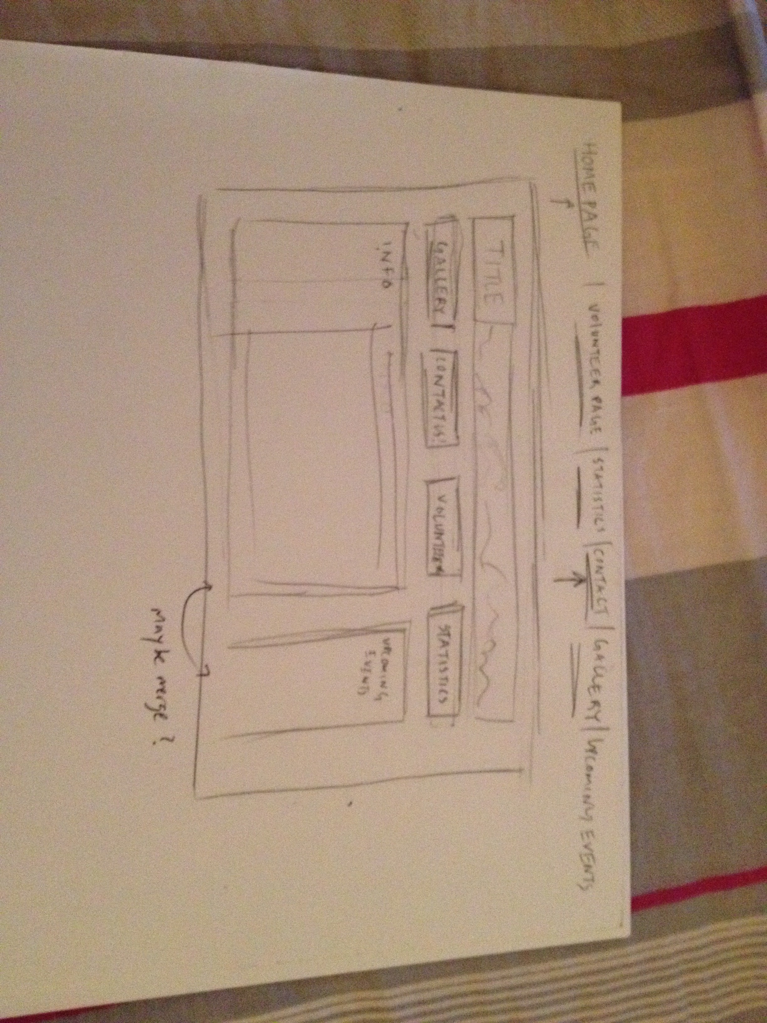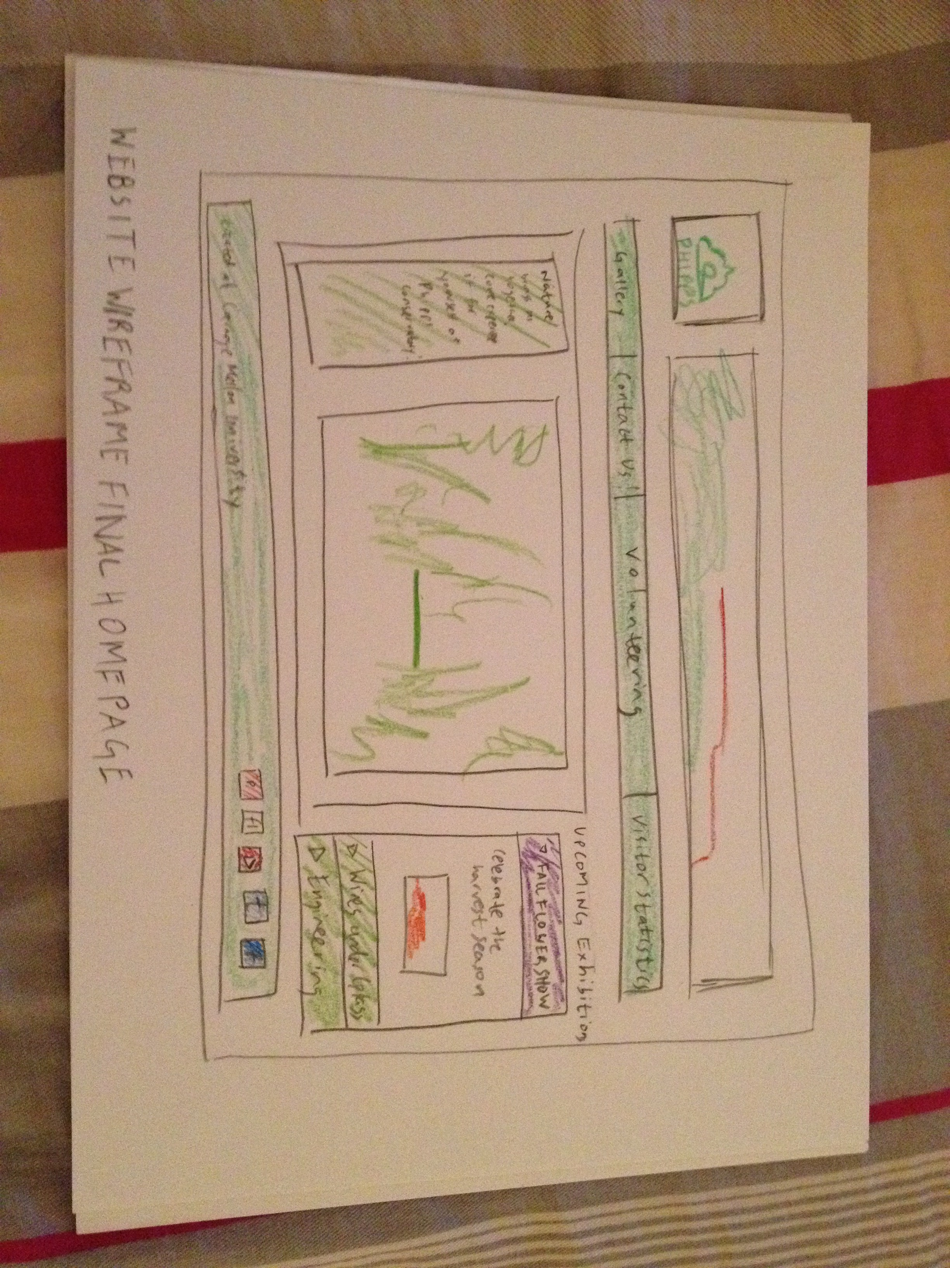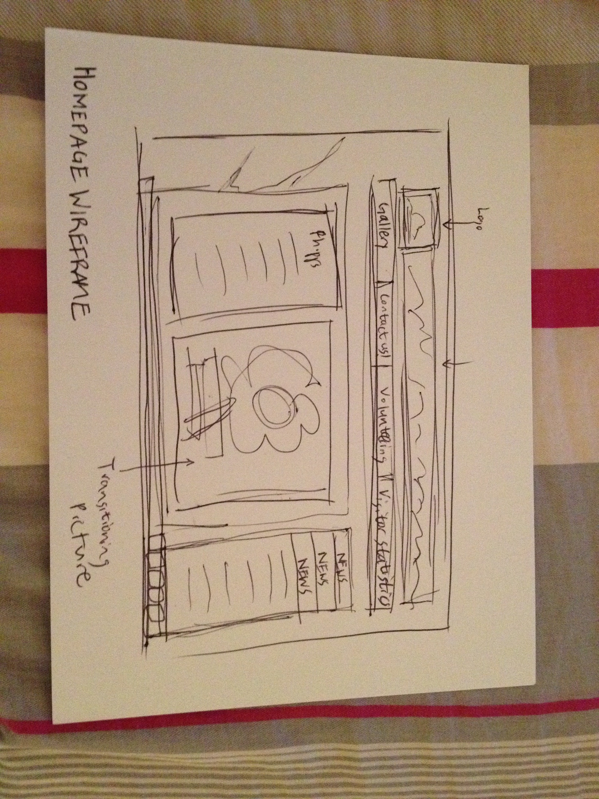**Exhibit A: Transformation of the homepage**

You can see clearly how the Upcoming Events box was changed to an accordion and how the buttons have been changed to a navbar.